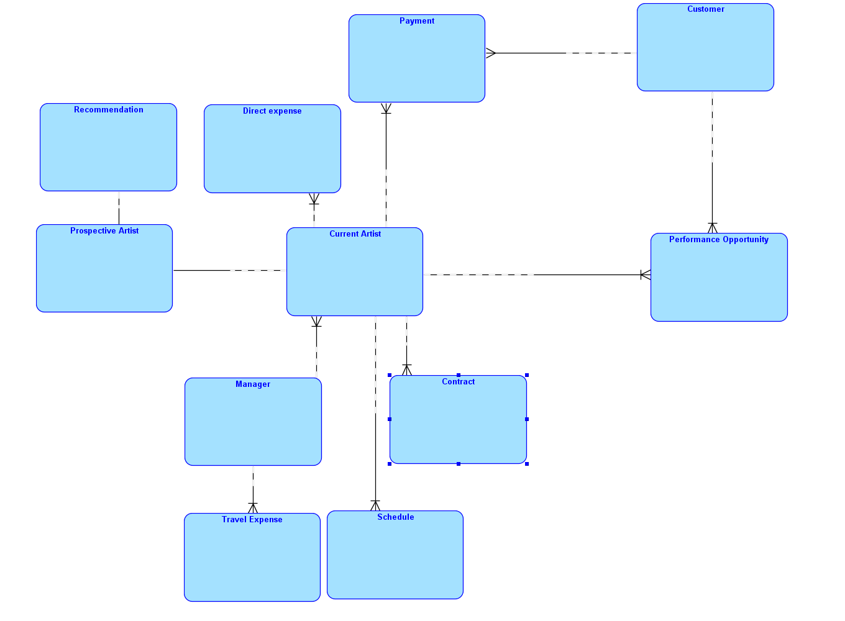

1. A manager may be in charge of multiple artists. An artist has only 1 manager.
2. Manager is responsible for their own travel expenses. A manager may have multiple travel records.
3. An artist is responsible for some direct expenses like advertisements, photos and flyers. An artist may have multiple kinds of direct expense.
4. The customer (concert hall/ opera houses) provide performance opportunities. A customer may provide multiple performance opportunities. An artist can participate in different places.
5. The customer pays after a performance is completed. A customer may make multiple payments. Similarly, an artist may receive multiple payments and could have multiple contracts.
6. A prospective may become the “current artist”. Thus the relation between these 2 entitities is 1-on-1.
7. Here we assume a prospective artist only receives one recommendation.